Autumn Term Interim Programmes Report 2025

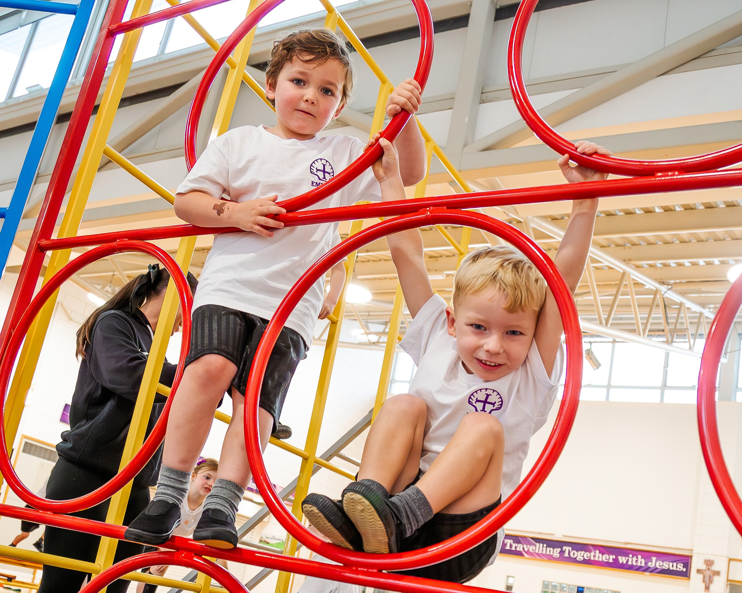
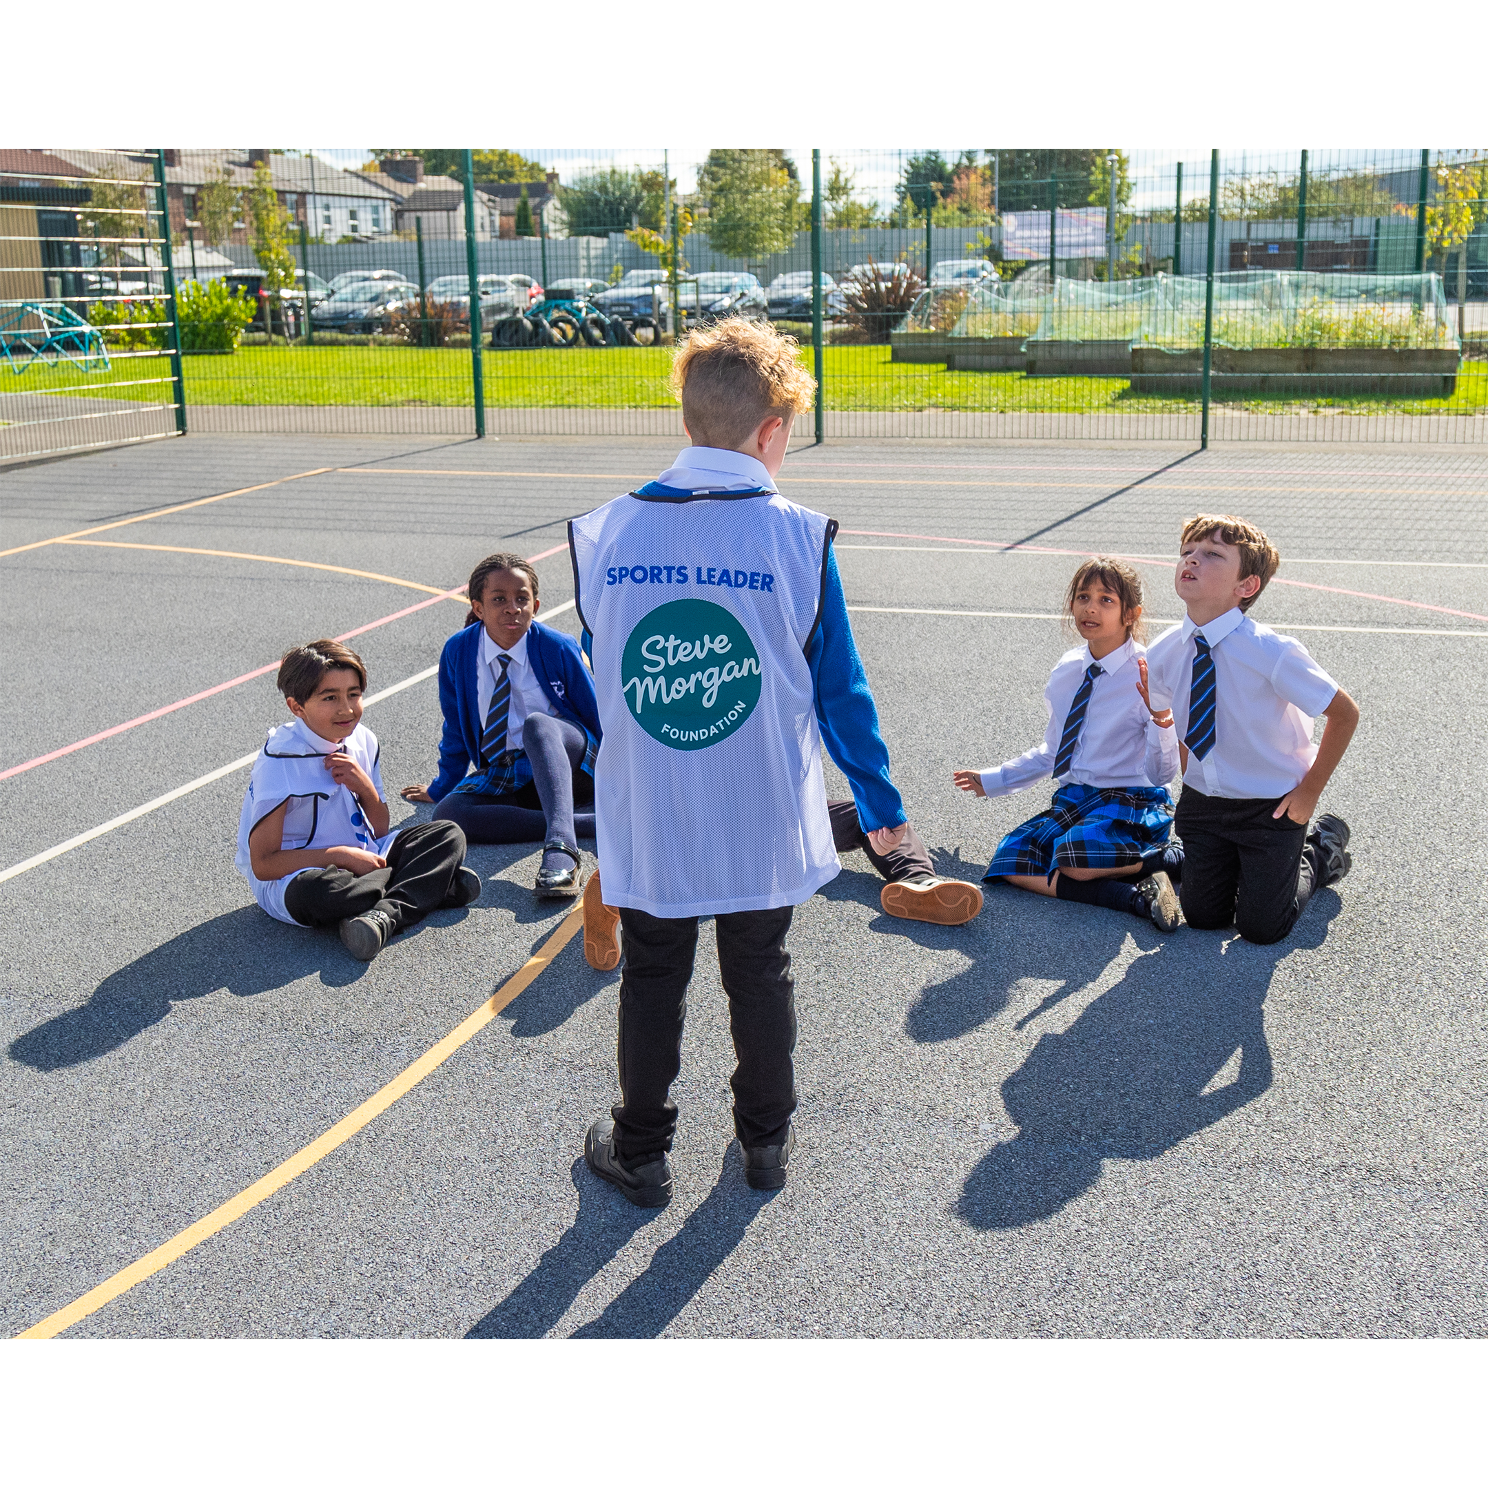
71 programmes have been delivered to 64 schools across Autumn term 1, with 63 Monitoring & Evaluation surveys returned to date.

Balanceability (Learn to cycle) 6 weekly sessions:

Number of schools | Number of children | Percentage schools happy with content | Percentage of schools happy with delivery
11 | 330 | 100% | 100%

Feedback from Schools
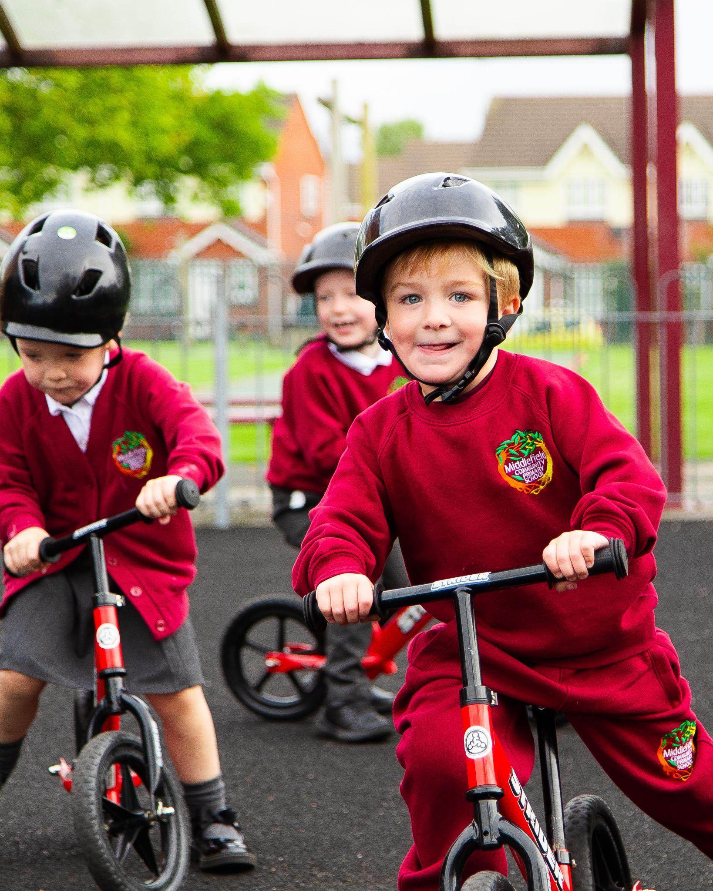
“The children enjoyed the sessions and the staff were professional and knowledgeable.”
Blueberry Park Primary School

“I felt this program had a positive impact on the children's gross and fine motor skills, core stability, and overall physical coordination. In addition, they had lots of fun during the sessions. Paul, the LSSP coach, was fantastic with the children.”
St. Austins Primary School

“Physical confidence in pupils who lack academic confidence which in Autumn term gave them peer appreciation. Others wanted to copy their successes.”
Middlefield Primary School

“Paul the LSSP coach was amazing with the children. He was punctual, professional and in LSSP kit.”
St. Austins Primary School

“LSSP coaches are always polite, helpful, professional and understanding which was especially noted with balance ability being with the Reception class children. I have nothing but praise for the team at LSSP.”
Kirkdale Primary School

“The children's confidence and self esteem was boosted: They enjoyed mastering new physical challenges and achieving the goal of riding a bike independently which many of them had not experienced before. This in turn provided them with a strong sense of accomplishment.”
St Vincent De Paul's Primary School

Skoot Skool (Learn to scoot safely) 6 weekly sessions:

Number of schools | Number of children | Percentage schools happy with content | Percentage of schools happy with delivery
7 | 252 | 100% | 100%

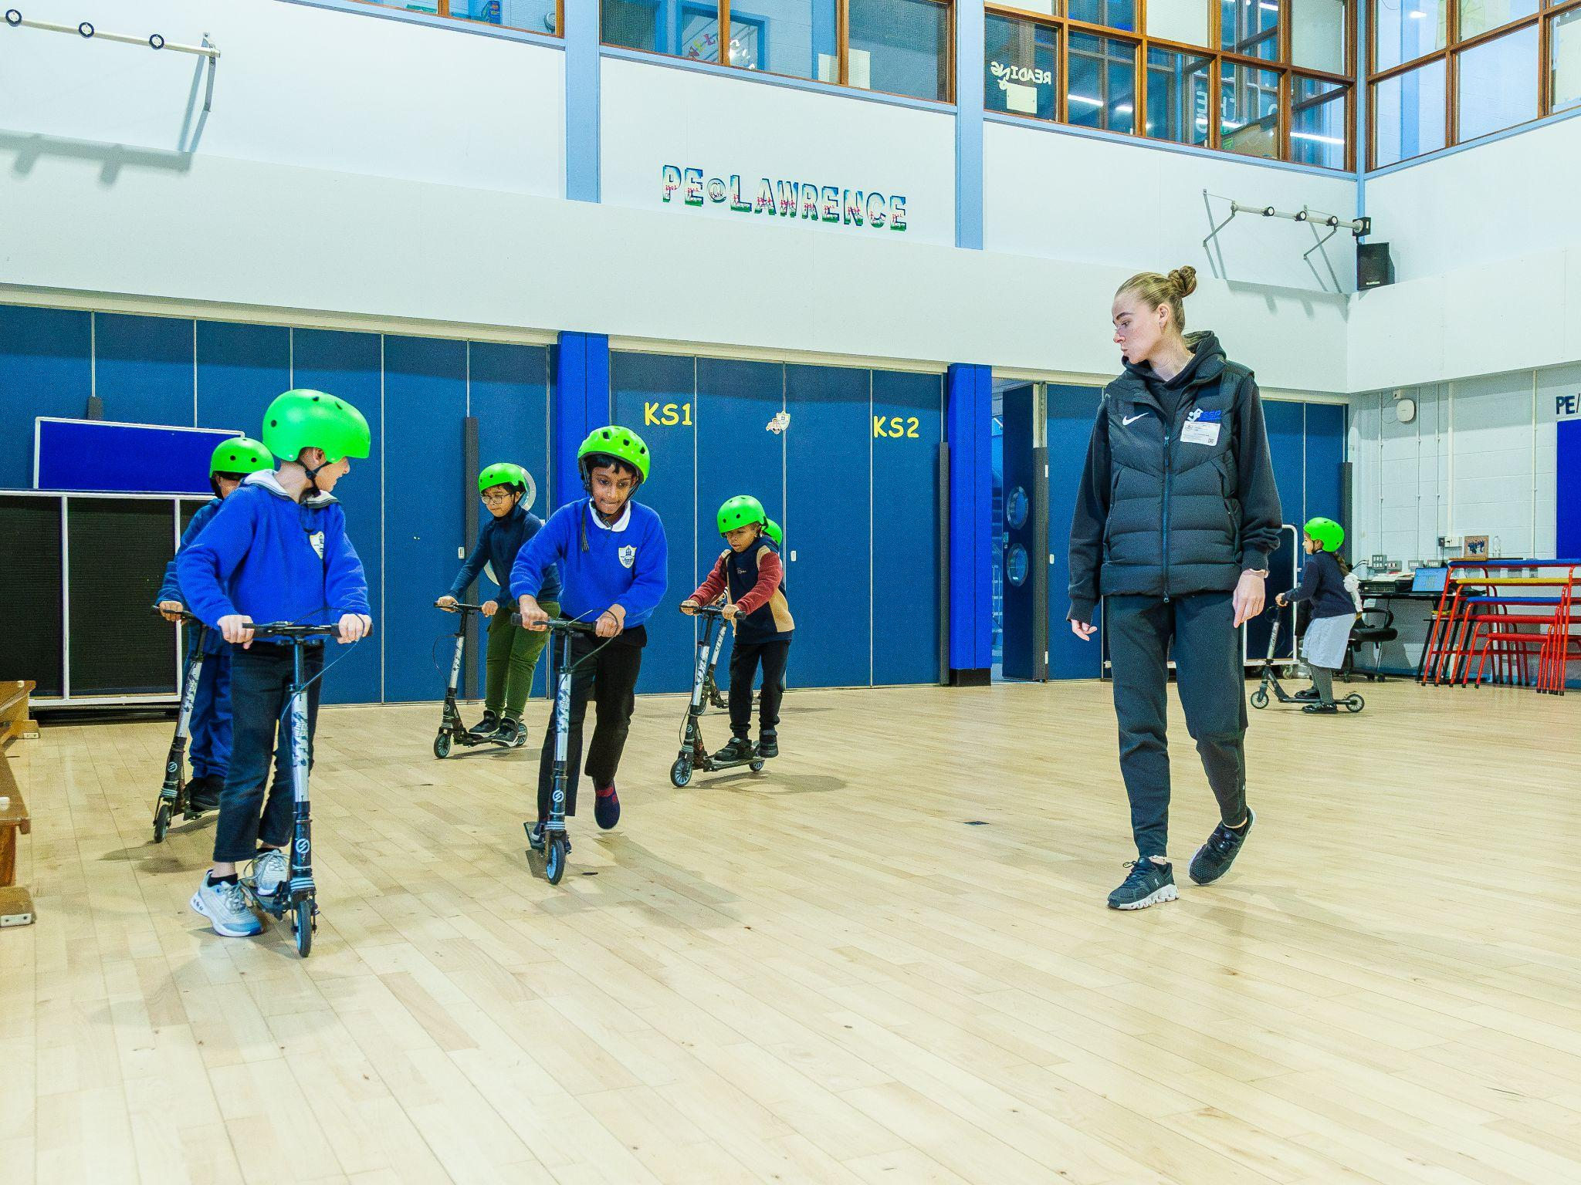
Feedback from Schools
“Our coach was on time every week, always had LSSP kit on, the way she was with the children was amazing. She's a credit to the company.”
Windsor Primary School

“I liked the progression of skills each week, with plenty of time during the sessions to develop such skills.”
Lawrence Road

“A really well planned and extremely well delivered programme.”

“Whenever they return back to class, the children are always eager to tell me what they've learned and even throughout the week are talking about their techniques.”
Woolton Primary School

“A lot of children who struggled at first have gained some resilience. Some of our children now talk about asking for a scooter for their birthdays/christmas and want to scoot to school. They have a really positive attitude following their sessions.”
St. Patricks Primary School

“We're very grateful that LSSP have provided us with amazing sessions which we would have otherwise missed out on. Can't fault the coaches or the programme, thank you very much!”
Pinehurst Primary School

“Great programme that extends beyond the classroom and curriculum.”
Rudston Primary School

Fundamental Movement Skills - 6 weekly sessions:

Number of schools | Number of children | Percentage schools happy with content | Percentage of schools happy with delivery
10 | 300 | 100% | 100%

Feedback from Schools
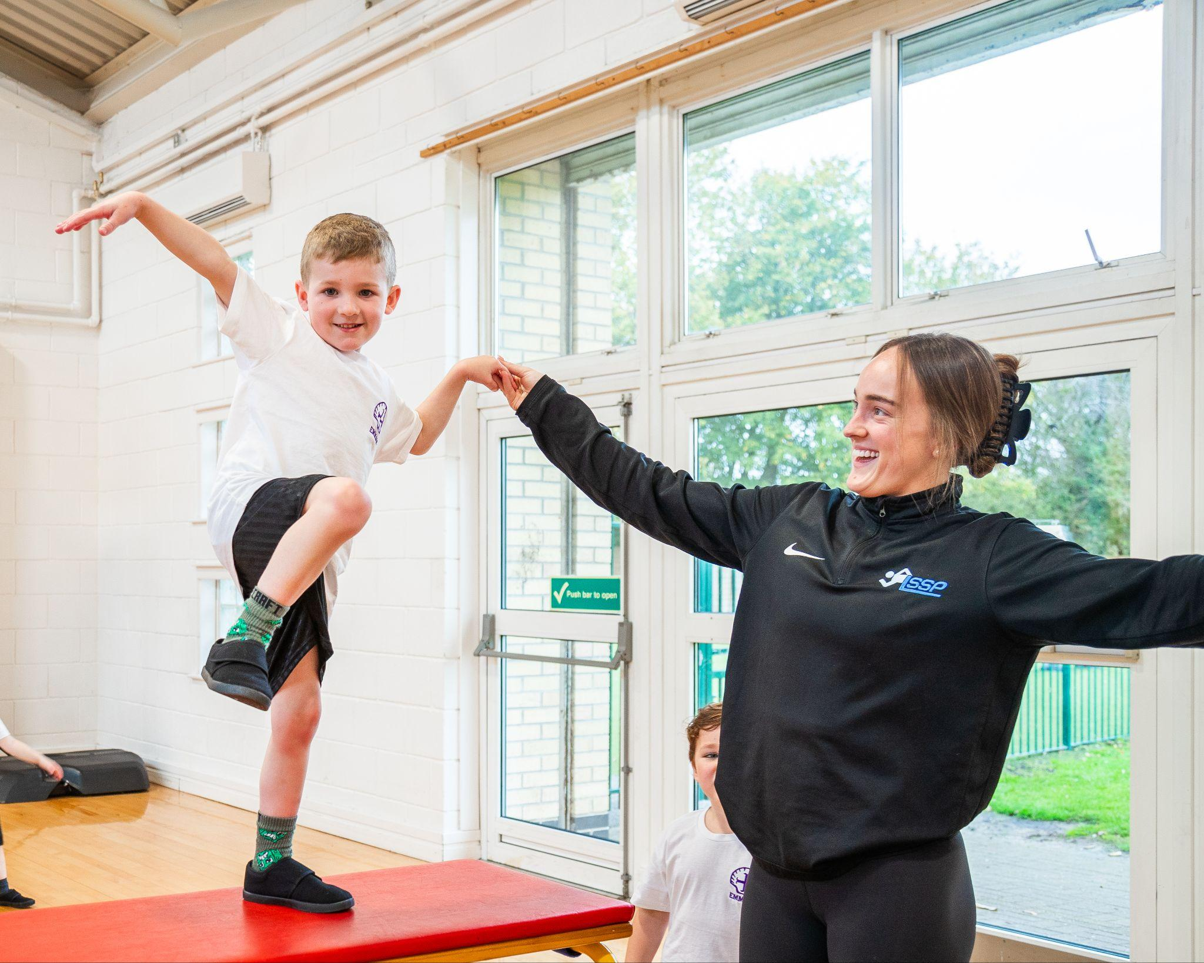
“We just wanted to say a huge thank you for your fantastic coaching of our EYFS children in Fundamentals. The children have absolutely loved every session, and the feedback from staff has been overwhelmingly positive, they've said you've been brilliant throughout. Your energy, enthusiasm, and ability to engage the little ones has made a real impact, and it's been wonderful to see them so excited and involved. We really appreciate the time and care you've put into making it such a great experience.”
Belle Vale Primary School

“I've done the feedback survey but just wanted to pass on how impressed we were with the fundamentals programme (we loved that it was linked to reading and traditional tales) and the coaches, Emma and Niamh. The children loved the whole experience - some of the children had only started school the week before the programme started. The sessions were pitched perfectly for their age and stage of development, very engaging with so many exciting ideas and resources, we could see their physical skills and confidence developing every week. The coaches were consistently professional, punctual and pleasant and proved that with the right level of support and encouragement, having ambitious expectations for our youngest children is not out of reach at all. We feel inspired to challenge them even more now. Please pass on our thanks to all involved and put us down for any future opportunities like this!”
Emmaus Primary (email)
“Feedback from staff and children involved was that they LOVED IT. (The coach was) Courteous, professional, knowledgeable and skilled. Yes, in LSSP kit.”
Smithdown Primary School
“The coach was fantastic with our children and delivered fantastic engaging sessions that the children really enjoyed. When asked the children could tell or show key information learnt.”
St. Gregory’s Primary School
“Paul was professional and knowledgeable as always. Always high quality sessions delivered by him.” Mathew Arnold Primary School

POWER - 6 weekly sessions:

Number of schools | Number of children | Percentage schools happy with content | Percentage of schools happy with delivery
10 | 600 | 71% | 71%

Feedback from Schools
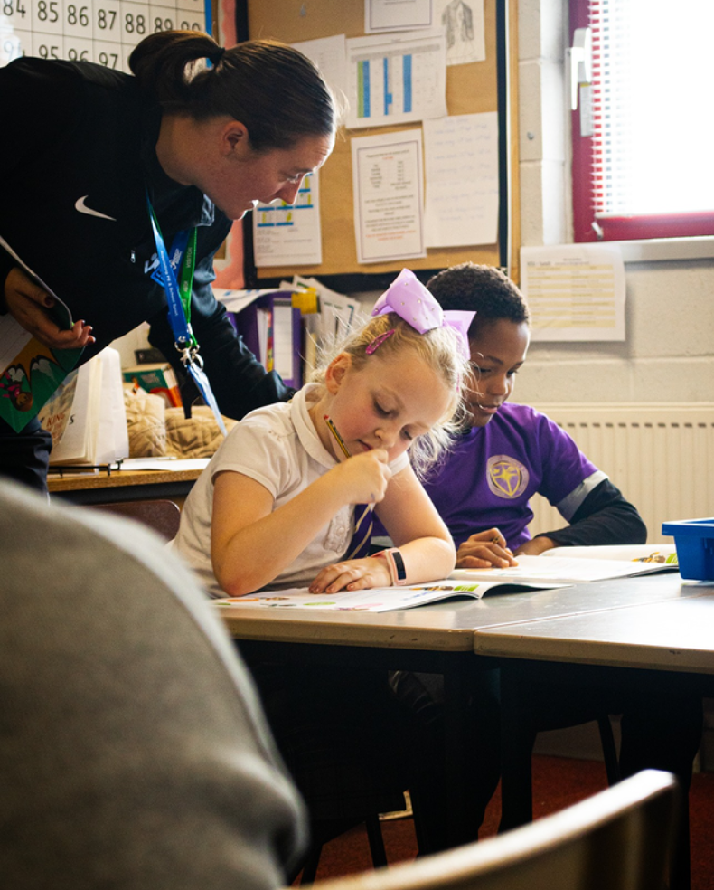
“There was not enough physical activity.”
St. Clare’s Primary School
“Improved confidence certainly. We selected children who may not have necessarily put themselves forwards for things, but got to shine during the Power delivery.”
Kingsley Primary School

“Small groups would have a greater impact.”
St. Oswalds Primary School

“Love the wide range of opportunities available, especially as they come into school, as it is difficult for us to get out.”
St. Clare’s Primary School
“They were able to retell what they had learnt to their classes at the end of each session.”
Rice lane Primary School
“I feel there could have been more work around the booklet the children were provided with. More discussion about the content and what it meant to the children. It seemed more weighted towards the physical side of the programme.”
Greenbank Primary School
“Seeing how the children I reacted with Kate and our additional staff member mentioned how much he enjoyed sitting in.”
Kingsley Primary School
“When asked in other subjects - they respond with the content from the Power programme.”

Mab Lane Primary School

Physical Activity Leaders Training - 2/3 weekly sessions:

Number of schools | Number of children | Percentage schools happy with content | Percentage of schools happy with delivery
21 | 336 | 100% | 100%

Feedback from Schools
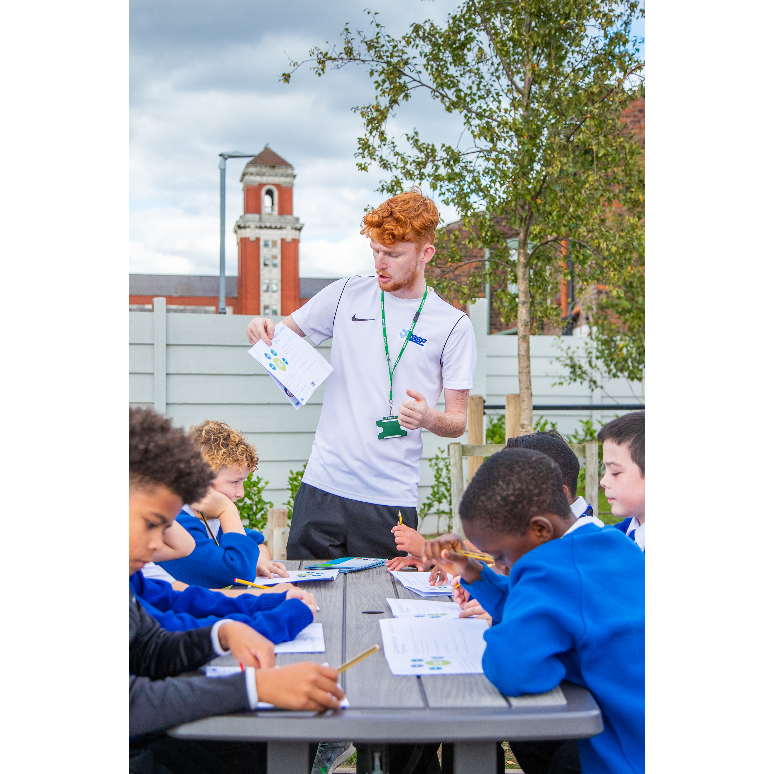
“Keep up, the fantastic work, the coaches we have had in school, Craig and Tom have been absolutely wonderful, so top marks and all praise to them.”
Smithdown Primary School

“The children really enjoyed the session and were really engaged and have put the training into practice at play times.”
Whitefield Primary School
“The confidence the sessions gave our playground leaders was fantastic. The positive way the children were made to think about the younger children and not just themselves. The children have been applying what they learnt daily during break and lunch times. ” Newpark Primary School
“Excellently led sessions, children enjoyed, developed and progressed.” St. Cecilia’s Primary School
“Pupils all enjoyed their sessions and are keen to begin their new roles in school this half term. They will also be supporting our OPAL playtimes too and using their new skills to support this.”
Much Woolton Primary School
“Content- staff said the Lunchtime Support Assistants session was beneficial to them.”
Childwall Valley Primary School
“Well organised. Trainer Georgia was excellent. Punctual, professional, friendly, in LSSP kit. Excellent.” St. Paul’s Primary School
“We see the impact of the training on the yard every day- less behaviour issues due to more activities going on.” Wellesbourne Primary School
“PALS leaders now lead playtimes with the KS1 children at playtimes. New resources have been ordered for this.” St. Charles’ Primary School

Personal Safety Training (DADDR) – Detect, Avoid, Defuse, Defend & Report: 2 Workshops

Number of schools | Number of children | Percentage schools happy with content | Percentage of schools happy with delivery
6 | 360 | 100% | 100%

Feedback from Schools
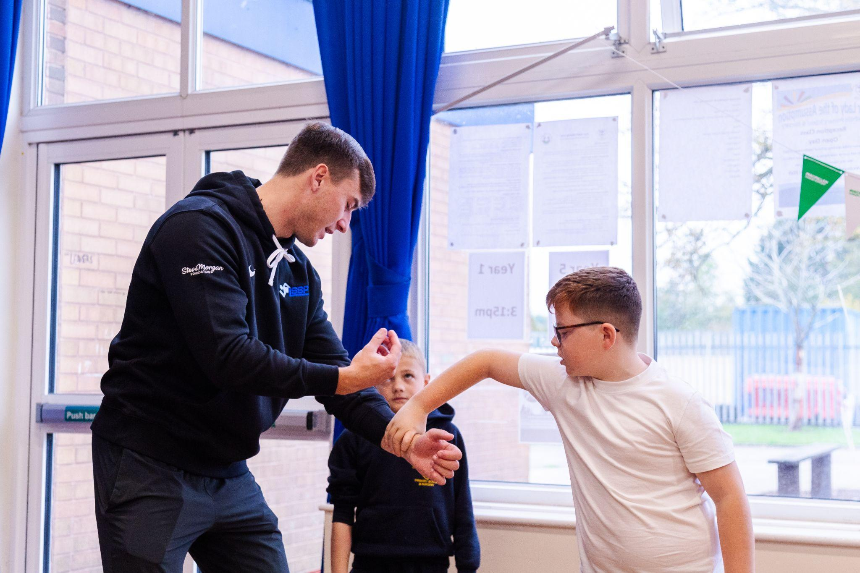
“Hi Adella, just wanted to say how well received DADDR was by our y6 pupils and their teachers. Everyone has said how brilliant Billy was and so if he was ever available to deliver this or any other sessions he does, in the future.”
St. Christopher’s Primary School
“The children really enjoyed the session with Coach Billy, who made the activities engaging, relatable and relevant for everyone involved. His approach kept all the children interested and motivated throughout and they clearly had fun while learning new skills.”
Our Lady of the Assumption Primary School
It was interactive, engaging and taught the children lots of valuable life skills.
St. Paschal Baylon Primary School
“The children were able to recall and explain the DADDR techniques after the sessions had finished. We will definitely be signing up for these sessions again in the future. Both members of staff were fantastic and the children thoroughly enjoyed the sessions. Thank you!”
St. Paschal Baylon Primary School
“We enjoyed all of the sessions. The teachers were fantastic and the children really enjoyed learning self-defence. Children have spoken about the skill they have learnt and were very excited to share messages with each other.”
Hunts Cross Primary School
“Children talking to parents about it at home and very positive feedback from children”
Greenbank Primary School

Outdoor & Adventurous Activities - 6 weekly sessions:

Number of schools | Number of children | Percentage schools happy with content | Percentage of schools happy with delivery
3 | 270 | 100% | 66%

“The delivery is key for all of these types of programmes. We just felt at times delivery was a little flat and not overly enthusiastic - which then showed in what the children got out of the sessions.
Knotty Ash Primary School

Children who don't normally speak to each other are playing with each other on the yard now and speaking to children in other years
Wellesbourne Primary School

“Children replicating games on their yard”
Childwall CE Primary School

Yoga and mindfulness - 6 weekly sessions:

Number of schools | Number of children | Percentage schools happy with content | Percentage of schools happy with delivery
3 | 270 | 100% | 100%

“Children and staff enjoyed yoga bears sessions. Instructor very knowledgeable and attentive to children's level of ability.”
Hunts Cross Primary School

“A great program and well attended after school club. Thank you.”
St. Christopher’s Primary School

